





**ADvantage Azure Intelligent Assistant [*ADAz.IA*]** is a Manifestation of **Human-Machine Partnership** through **Intelligent Business Conversation** for diverse **queries and reactive / proactive Actions** on various **Industry specific Digital Functions**



* Multi Brain / User / Mode / Recipe / Omni Channel
* Integrated non-BOT & BOT-BOT with Use Case Visualization
* NLU / NLP / NLG / NLQ aggregation
* Auto AI Generation / Auto Form Recognition
* Use Case / Conversation / Cultural Diversity
* State, Context & Persona Sensitivity
* Speech Capabilities & Voice Genomics
* Simplified and Controlled AI Learning
* Power User driven AI Ecosystem Management
* Accuracy Boosters, CUI Monitoring & Analytics
* Employee Help Desk *at Global Retail & CPG Giant*
* Patients’ Voice partner *for US Healthcare Giant*
* Process Automation Agent *for Swiss Pharma Giant*
* Retail Banking Customer Agent *for German Bank*
* Tax Consultancy Service Desk *for EU Financial Major*
* Pizza Ordering Agent *for American Food Chain*
* Human Resource Assistant *for Top Australian Bank*
* Program DevOps Assistant *for Irish Manufacturer*
* Portal Search Agent *for Global Confectioners Giant*
* Focused Business & Industry Solution
* Infinite Scalability & Limitless Portability
* Technology Agnosticism & On Demand Multi Culture
* Automated AI Generation & Voice Genomics
* Power User Empowerment & Simplified Training
* Container Enabled & Use Case Visualization
* TRUE Omnichannel with High Accuracy

**Support**

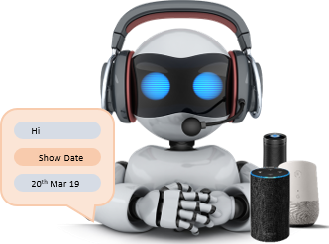

Ongoing Execution of Troubleshooting & Continuous Improvement

Phased Optimal Execution

Strategic Guidance Plan & Design Enterprise AI

**Implementation**

**Advisory**

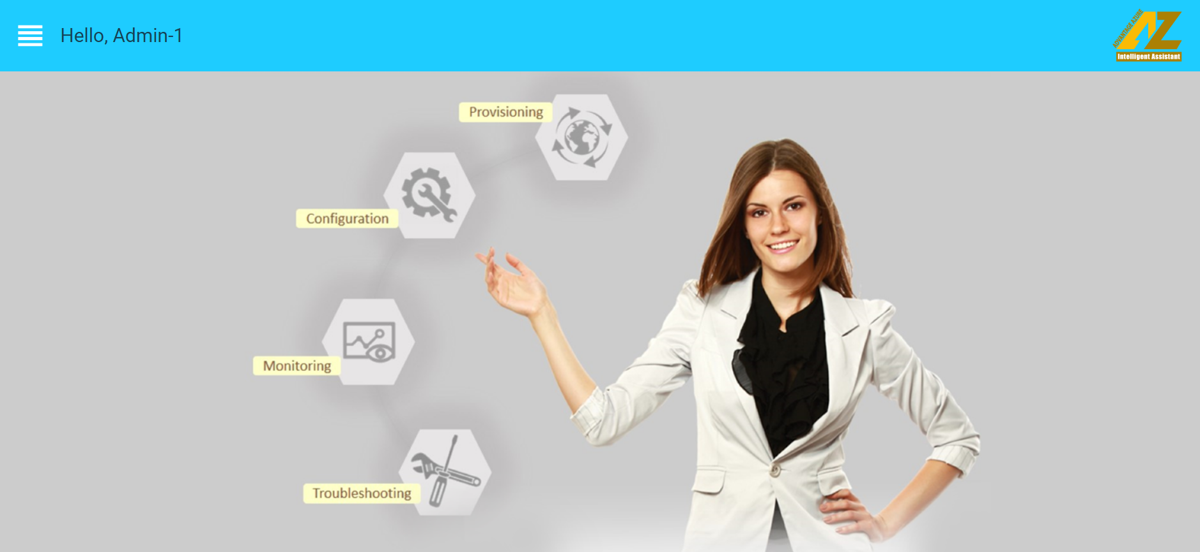

**Salient Features**

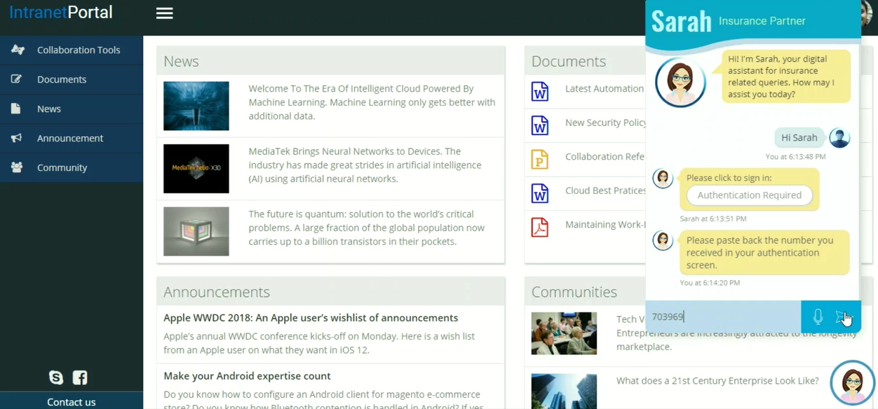

**Recent Cases**

**Service Portfolio**

**Why ADAz.IA**